

**TECHNICAL DESIGN DOCUMENT - DEV PHASE 3**

**Prepared by :** ANAND RAJ B

**Feature Name :** Challenges and Life Lines Features

**Date :** 19-11-2024

**Version :** 1.0.0

**Organisation :** Venzo technologiespvt ltd

**Contact** **:** anandrajb@venzotechnologies.com

| Version | Date | Author | Comments |
| --- | --- | --- | --- |
| V 0.1 | 19-11-2024 | ANAND RAJ B | Initial Draft |
| V 0.2 | 27-11-2024 | ANAND RAJ B | Updated schema information |

| **S.No** | **Content** | **Page** |
| --- | --- | --- |
| 1 | Introduction | 2 |
| 2 | System Architecture | 3 |
| 3 | Data Models and Schemas | 4 |
| 4 | Technical Components | 6 |
| 5 | Conclusion | 8 |

**\*\*** This document frames the TDD / TSD for the phase 3 development of tf masters application features and I believe in pushing the boundaries of what's possible . Feel free to adjust based on your requirements and knowledge.

**INTRODUCTION**

**1.1 General Information**

This document outlines the technical specifications for Project Trade Finance Masters (TFM) followed by Phase 3 sprint of development planned on (11-Nov-2024) which primarily focuses on the upcoming new features and enhancement plans .

The intended audience for TFM includes researchers across various disciplines, Consultants seeking to derive actionable insights from their data and knowledge .

**1.2 Purpose**

The purpose of the System Requirements document is to specify the overall system requirements for TFM that will govern the development and implementation of the system. The document will also establish initial security, training, capacity and system architecture requirements, as well as, system acceptance criteria agreed upon by the key stakeholders.

**1.3 Abbreviation**

**FK -** Foreign Key

**M2M** - Many to Many

**WS** - Websockets

**UTC** - Universal Time zone

**CMS** - Content Management System

**API** - Application Programming Interface

**\*\*** Introduction mentioned only for the P3 sprint development features and insights , feel free to adjust the required items

**SYSTEM ARCHITECTURE**

**2.1 Overview**

**2.1.1 -** The **Challenges** features requires both client and server efforts for:

- Database System

- CMS

- Redis Cache for data caching

**DATA MODELS AND SCHEMAS**

**3.1 Overview**

The Data Model overview drafts how the data is managed and stored in the database as a table . The overview follows for the challenge and lifeline features only .

**Existing Tables**

**3.1.2 Challenge Topics**

| id | UUID / Auto Increment |
| --- | --- |
| name | varchar |
| created_at | Timestamp |
| update_at | Timestamp |

**3.1.1 Challenges Records**

| id | UUID / Auto Increment |
| --- | --- |
| name | varchar |
| description | text |
| no_of_questions | int |
| starts_on | Timestamp |
| ends_on | Timestamp |
| questions | M2M (questions) |
| challenge_topics | M2M (challenge topics) |
| life_lines | M2M (life lines) |
| challenge_status | varchar |
| created_at | Timestamp |
| update_at | Timestamp |

**\*\* Challenge status as ACTIVE / DRAFT**

**3.1.6 Questions**

| id | UUID / Auto Increment |
| --- | --- |
| name | varchar |
| duration | timefield |
| topic | FK (topics) |
| question_type | varchar |
| explanation | text |
| points | int |
| difficulty_level | varchar |
| created_at | Timestamp |
| update_at | Timestamp |

**\*\* question_type can be MCQ / FILLUP / T-F**

**\*\* difficulty level can be BEGINNER / INTERMEDIATE / EXPERT**

**3.1.7 Answer**

| id | UUID / Auto Increment |
| --- | --- |
| content | varchar |
| is_correct | bool |
| question_id | FK (questions) |

**3.1.8 Challenges Taken**

| id | UUID / Auto Increment |
| --- | --- |
| challenge_id | FK (challenge) |
| user_id | FK (user) |
| position | int |
| earned_coins | int |
| is_paused | bool |
| attempts | FK (challenge attempts) |
| created_at | Timestamp |
| update_at | Timestamp |

**3.1.9 ChallengesTaken Attempts**

| id | UUID / Auto Increment |
| --- | --- |
| challenge_id | FK (challenge) |
| time_taken | timefield |
| attempted_questions | int |
| correct_answers | int |
| first_attempt | bool |
| attempt_information | JSON |
| created_at | Timestamp |
| update_at | Timestamp |

**New Tables**

**3.1.3 Life Lines**

| id | UUID / Auto Increment |
| --- | --- |
| name | varchar |
| Description | varchar |

**3.1.4 Challenge Feedbacks**

| id | UUID / Auto Increment |
| --- | --- |
| user | FK (user) |
| Feedback_type | varchar |
| challenge | FK (user) |

**\*\*Feedback type can be GOOD / MEDIUM / BAD**

**3.1.5 Congratulatory**

| id | UUID / Auto Increment |
| --- | --- |
| name | varchar |
| wish_type | varchar |

**3.2 Schema Information**

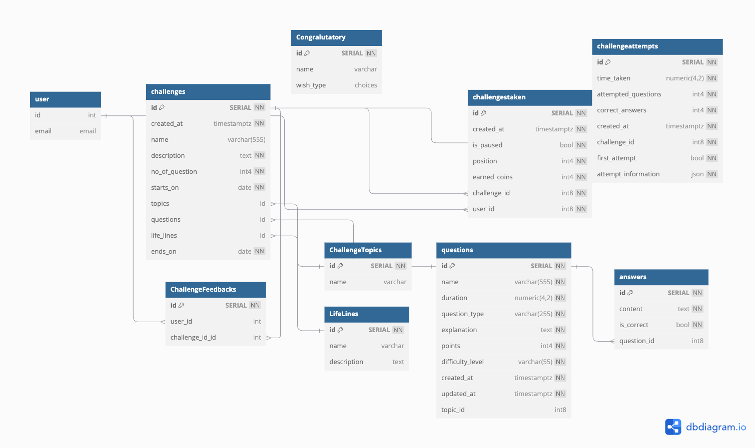

Fig 3.1 Challenges Schema

**TECHNICAL COMPONENTS**

**3.1 overview**

The technical components overview describes the endpoints for challenges and life line information with an API based HTTP protocol communication .

**3.2 End points information**

**3.2.1 All Challenges**

| **Request Type** | **GET**  /api/v3/gamification/challenges |
| --- | --- |
| **Description** | Displays all the challenges  E.g Response  Response :  {  "status": "Success",  "data": {}  } |

**3.2.1 Challenge by type**

| **Request Type** | **GET**  /api/v3/gamification/challenges/?challenge_type=ATTEMPTED |
| --- | --- |
| **Description** | Displays all the challenges by the challenge type  I.e., challenge type can be ATTEMPTED / UNATTEMPTED  E.g Response  Response :  {  "status": "Success",  "data": {}  } |

**3.2.2 Challenge by categories**

| **Request Type** | **GET** /api/v3/gamification/challenges/?categories=[“banking”,”letter of credit”] |
| --- | --- |
| **Response** | E.g Response  Payload : None  Response :  {  "status": "Success",  "data": {}  } |

**3.2.3 Challenge Sorting**

| **Request Type** | **GET**  /api/v3/gamification/challenges/?sort_by=NEWEST |
| --- | --- |
| **Response** | Displays all the challenges by the sorted type  I.e., sort types can be NEWEST , OLDEST , POPULAR  Response :  {  "status": "Success",  "data": {}  } |

**3.2.3 Challenge Submit**

| **Request Type** | **POST**  /api/v3/gamification/challenges/submit/ |
| --- | --- |
| **Response** | Payload :   {  “Challenge_id” : 12,  “User_id” : 12,  “Attempt_information” : {} }  Response :  {  "status": "Success",  "data": {}  } |

**3.2.2 Life Lines**

| **Request Type** | **GET** /api/v3/gamification/challenges/?categories=[“banking”,”letter of credit”] |
| --- | --- |
| **Response** | E.g Response  Payload : None  Response :  {  "status": "Success",  "data": {}  } |

**3.2.2 Leaderboards**

| **Request Type** | **GET** /api/v3/gamification/leaderboards/?challenge_id=133 |
| --- | --- |
| **Response** | E.g Response  Response :  {  "status": "Success",  "data": {}  } |

**3.2.2 Challenge Summary**

| **Request Type** | **GET** /api/v3/gamification/challenges-taken/summary/?challenge_id=133 |
| --- | --- |
| **Response** | E.g Response  Response :  {  "status": "Success",  "data": {}  } |

**3.2.2 Challenge Feedbacks**

| **Request Type** | **POST** /api/v3/gamification/challenge/feedback |
| --- | --- |
| **Response** | E.g Response  Payload :  {  “User” :121,  “Feedback” : “GOOD” }  Response :  {  "status": "Success",  "data": {}  } |

**3.3 Required Entity**

**Backend**

* **CMS** for content management in django admin backend
* **Redis** for data caching for least recently used challenges information
* **API** for data interaction

**Frontend**

- **API Handling** For challenges flow and UI data displaying

**3.3 Interaction**

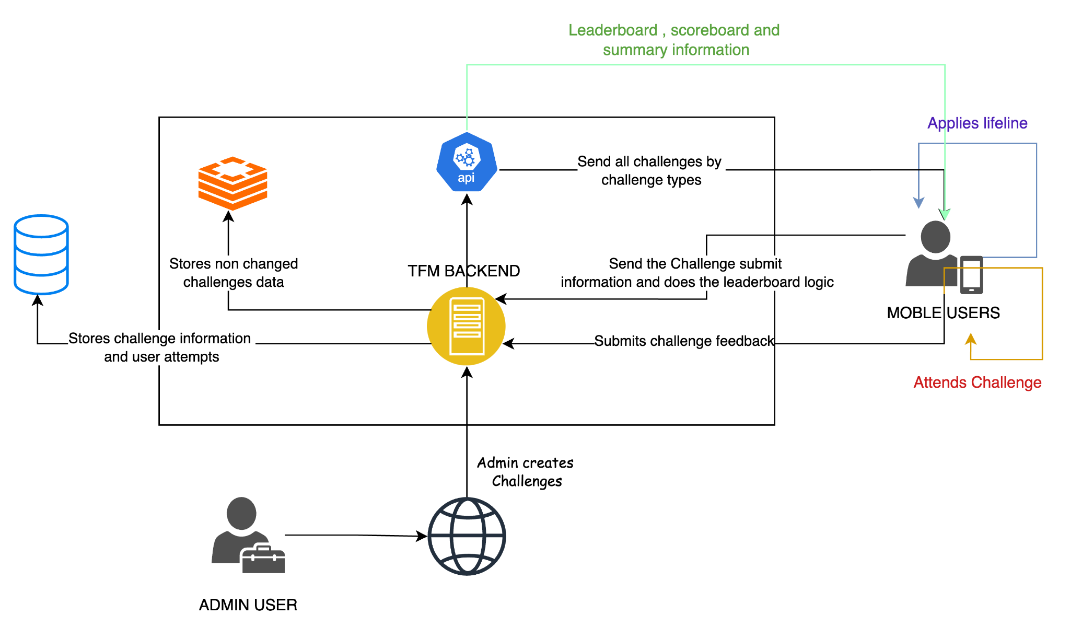

Fig 3.2 Flow interaction Diagram

**CONCLUSION**

Implementing Technical Design Document (TDD) for TFM enhances software quality and boosts developer productivity. By identifying bugs early in the development cycle, TDD reduces long-term debugging efforts and improves reliability. While TDD may initially seem time-consuming, its benefits significantly outweigh the upfront investment, leading to more robust and efficient development processes.

Sincerely ,

ANAND RAJ B

SDE-3

[anandrajb@venzotechnologies.com](mailto:anandrajb@venzotechnologies.com)

+91 9677 210 269

